Operating Systems

Linux Kernel Threads

Lab Report

David O Neill

0813001

Example 1

The main function runs is executed, malloc() allocates memory for the thread's stack. The main function then prints 'Creating child thread' to the standard output.

The clone() system call creates a new thread who's entry point is the function signature 'threadFunction( void* argument )'. The second argument is a pointer to a memory space to be used as the stack for the new thread. The third argument is the flags inherited by the parent process. The last argument is the argument passed to the threads function signature. On successful creation of the thread a Process ID is returned or -1 indicating failure.

The child thread then runs printing 'child thread exiting' to the standard output stream before returning. The parent thread during this time continues executing before the system call waitpid() is called. This suspends the parent process's execution until the child specific by a PID argument has changed state. The status of the thread can be stored in a pointer specified in the second argument. Options can be passed to the thread execution in the form of constants.

Finally after the child process (thread) has finished its memory is freed using free(). The parent process then prints 'Child thread returned and stack freed' to the standard output.
If in the event of any errors, perror() is used to print errors the the standard error stream.

See Fig. 1.1

Example 1 Extended

In the extended version we duplicate our work for malloc(), allocating two stacks (memory spaces), one for each thread. The parent prints 'Creating child threads'.
Two child processes (threads) are then created. Thread 1 executes incrementing the value of x. In this case it happens before thread 2 has a chance to modify the data possibly causing a shared data inconsistency. This is because there is no mutual exclusion algorithm to prevent the simultaneous use of the shared resource x.

Possible Problem
In the threads critical section namely the atomic operation x++, this resource can be read into a CPU's register and incremented in the accumulator while Thread 2 is loading the value from the memory. Since the value in memory has not yet been updated by Thread 1, Thread 2 now has a old value of X. And the result of the atomic operation of Thread 2 (x++) will be same as Thread 1's atomic operation which has yet to be stored back into memory. Hence a shared data inconsistency.

Test Case
In this cause however thread 1 is is not pre-empted by the Kernel process scheduler dispatcher and is allowed to perform its atomic instruction, saving the data back into memory before Thread 2 begins its atomic operation. Thread 2 performs its atomic operation incrementing x and stores x back into shared memory.

Once again we wait for these 2 threads to complete using waitpid() before continuing the execution of the parent process. The two stacks are then freed using free(). The parent then prints 'Child threads returned and stacks freed.' and exits.

See Fig. 1.2

Example 2 – Producer – Consumer

In example 2 the producer produces 10 items before the consumer thread is allowed to begin. As waitpid() is called on producer before the consumer begins, the consumer does not consume until the producer has finished executing.

See Fig. 2.1

As the buffer array is 20 the producer does not reach a deadlock situation, where it is waiting for items to be consumed before it can produce more items.
Changing the buffer to size 5 illustrates this deadlock situation.

See Fig. 2.2

By removing the waitpid( pid_producer, 0, 0 ); instruction after the thread creation and putting it after the consumer thread we now have multi-threaded concurrent execution of the producer and the consumer.

See Fig. 2.3

During the stages of the consumer and the producer lifetime, as context switches occur we can see non synchronization of the 2 threads in the producing and the consuming stages.
Because the buffer is of size twenty and the producer only producers 10 items we don't reach a deadlock situation where the producer is waiting for the consumer to consume an item based upon the shared variable count (semaphore).
If we change the buffer size to 5 we can see this deadlock situation.

See Fig. 2.2

As count (semaphore) is critical to both the consumer and the producer and neither have mutual exclusion over this value. If the producer / consumer are pre-empted while working with atomic operation count++ or count-- a shared data inconsistency can occur causing the wait loops in
Producer : while (count == BUFFER_SIZE); // wait
Consumer : while (count == 0); // wait
to cause a deadlock situation.
In this situation the consumer is in the starvation scenario (indefinite blocking) as the semaphore count is now zero and the consumer has not finished its consumption of 10 items.
See Fig. 2.4

Example 3 - Peterson's Algorithm

Running example 3 we can observe that again that there is no mutual exclusion over the semaphore count. This results in a deadlock situation again where the consumer is trying to consume but it is being blocked by 'if (count > 0) {'.

The critical sections
The critical sections for the consumer and producer

See Fig. 3.2 & Fig. 3.3

Peterson's Algorithm
In order to implement Peterson's algorithm we need two shared variables flag and turn. We assume that the load and store for count++ and count-- are atomic instructions. Turn indicates who's turn it is to enter there critical section. The flag array is used to indicate if a process is ready to enter their critical section. Flag[P] = 1 implies a process is ready. Executing our modified code we can now see there is mutual exclusion over the semaphore count.

See Fig. 3.1

Before the Producer enters its critical section it sets the flag equal to 1 indicating it wants to enter its critical section. When it leaves its critical section it sets flag equal to 0 indicating it is finished with its critical section.
If the producer gets to the wait signal ' while (flag[1] && turn==1); ' it will wait here until the consumer is done with its critical section. The consumer sets its ready flag to 0 indicating it is done with its critical section. The producer will then break out of this waiting and continue with its critical section.

If a context switch then occurs during the producer's critical section the consumer will be waiting at its wait signal ' while (flag[0] && turn==0); ' until the producer exits its critical section setting its flag = 0 indicating it is done.
Extend this to example 2

Example 4 – Mutex Locks

Running example 4 we can observe that the 2 threads are created. On entering the thread function each thread tried to obtain a mutual exclusion lock on the mutex mutex1. Mutexes are used to prevent data inconsistencies due to race conditions and enabling successful thread synchronization.
Whichever thread gets the lock first will proceed into its critical section. The other thread will wait till the mutex lock has been freed by the other.

See Fig. 3.4

Critical section
The critical section of the thread block requests the shared value of counter and assigns it to a local variable newcounter. This variable is then incremented, the thread is told to sleep for one second and the counter shared variable counter is then assigned the value of newcounter. The thread prints the value of counter and then finally the mutual exclusion lock on the mutex mutex1 is freed.
Once the first thread has completed its critical section the the mutex mutex1 is unlocked, the second thread will then be allowed to get a mutual exclusion lock on the mutex mutex1 and it will proceed into the critical section.

pthread_create
The function signature pthread_create accepts four arguments.
thread – Thread thread id or reference to (thread)
attributes – constants which specify attributes of the threads execution states*
start routine – a reference to the function to be executed as the threads entry point
args – a pointer to an argument to send to the threads or a pointer to a data structure containing multiple arguments.
The return type of pthread_create is an integer. On success, the identifier of the newly created thread is stored in the location pointed by the thread argument, and a 0 is returned. On error, a non-zero error code is returned.

pthread_join
Waits for a termination of another thread and accepts two arguments. The thread to wait for and the return value of the thread. If the thread returns 0 it means the threaded completed successfully. On error a non zero value is returned. In the test case a NULL value is specified in the second argument meaning that we don't care about its return value. It suspends the calling thread until until termination of the thread is completed whether through cancellation or termination.

Removing the mutex
Removing the mutex mutex1 and pthread_mutex_lock() from the thread function entry point.
We can observe a problem with the alteration after executing the code. There is now no mutual exclusion on the shared variable counter. Both threads will now race to get this counter followed by sleep(1) (sleep for one second), As the Kernel process scheduler dispatcher (context switch) is supposed to have a response time of <1 second. Thread one does not get the opportunity to store the new value of counter ( P' = P + 1), before the second thread loads the value of P. So even if there was a delay on the creation of thread 2, we still could not guarantee that sleep(1) would finish waiting allowing P' to be stored back to memory. As a context switch would most likely occur allowing thread 2 to load P it results in both threads storing the same value back to the shared memory.

See Fig. 3.5

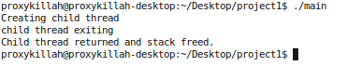
Figure 1.1 (clone and waitpid)

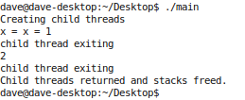

Figure 1.2 (No mutual exclusion, lucky this time!)

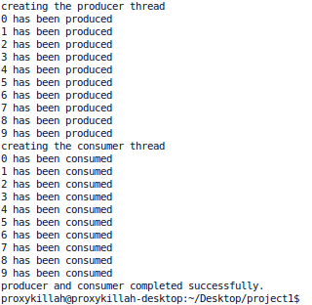

Figure 2.1 (Non concurrent)

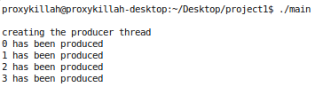

Figure 2.2 (Deadlock)

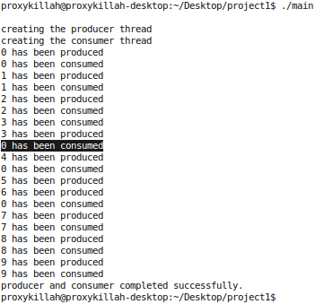

Figure 2.3 (Concurrent execution)

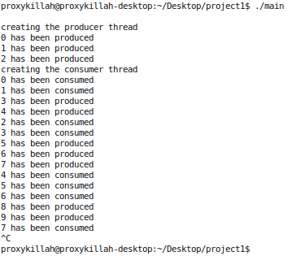
Figure 2.4 (Starvation deadlock)

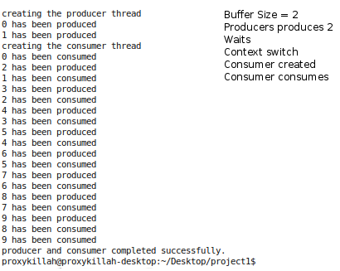

Figure 3.1 (mutual exclusion Peterson's Algorithm)

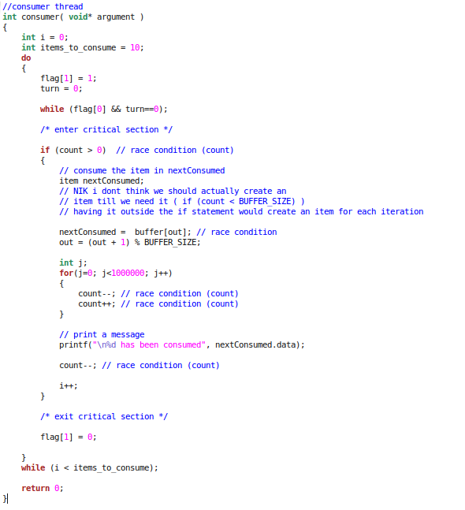
Figure 3.2 (Consumer Peterson's Algorithm)

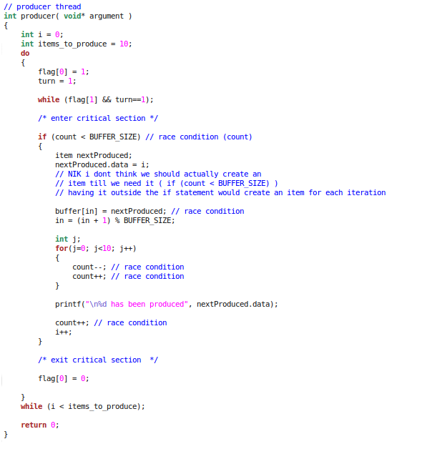
Figure 3.3 (Producer Peterson's Algorithm)

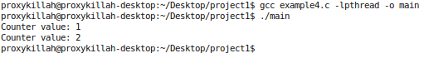
Figure 3.4 (Mutex Lock)

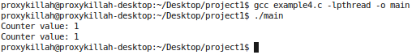
Figure 3.5 (No Mutex Lock)

